MACHINE LEARNING • CUSTOMER RETENTION • BUSINESS INSIGHTS
Predictive Customer Churn Model
Telecom Company – ConnectTel

Project Report

1. Project Overview
Goal | Approach | Outcome
Predict customers who are likely to churn before they leave. | EDA → feature engineering → preprocessing → ML → tuning → SHAP | Select the strongest model and convert predictions into retention actions.

Project Scope
- Dataset: Telco Customer Churn
- Models: Logistic Regression, Random Forest, XGBoost
- Evaluation focus: AUC-ROC, Precision and Recall

2. Problem Statement & Objectives
- Predict customers who are likely to churn.
- Identify customer, service, contract and billing factors associated with churn.
- Compare three machine learning classification models.
- Use cross-validation and hyperparameter tuning to improve model selection.
- Provide actionable recommendations for customer retention.

3. Dataset & Target Variable
7,043  Customer records | 21  Original columns | 26.54%  Overall churn

What the Data Covers
- Customer demographics and partner/dependent information
- Services such as Internet, security, support and streaming
- Contract and payment information
- Tenure and billing information
Target variable: Churn (Yes / No)

4. Exploratory Data Analysis
The dataset shows a moderate class imbalance, with roughly three-quarters of customers retained and just over a quarter churned.
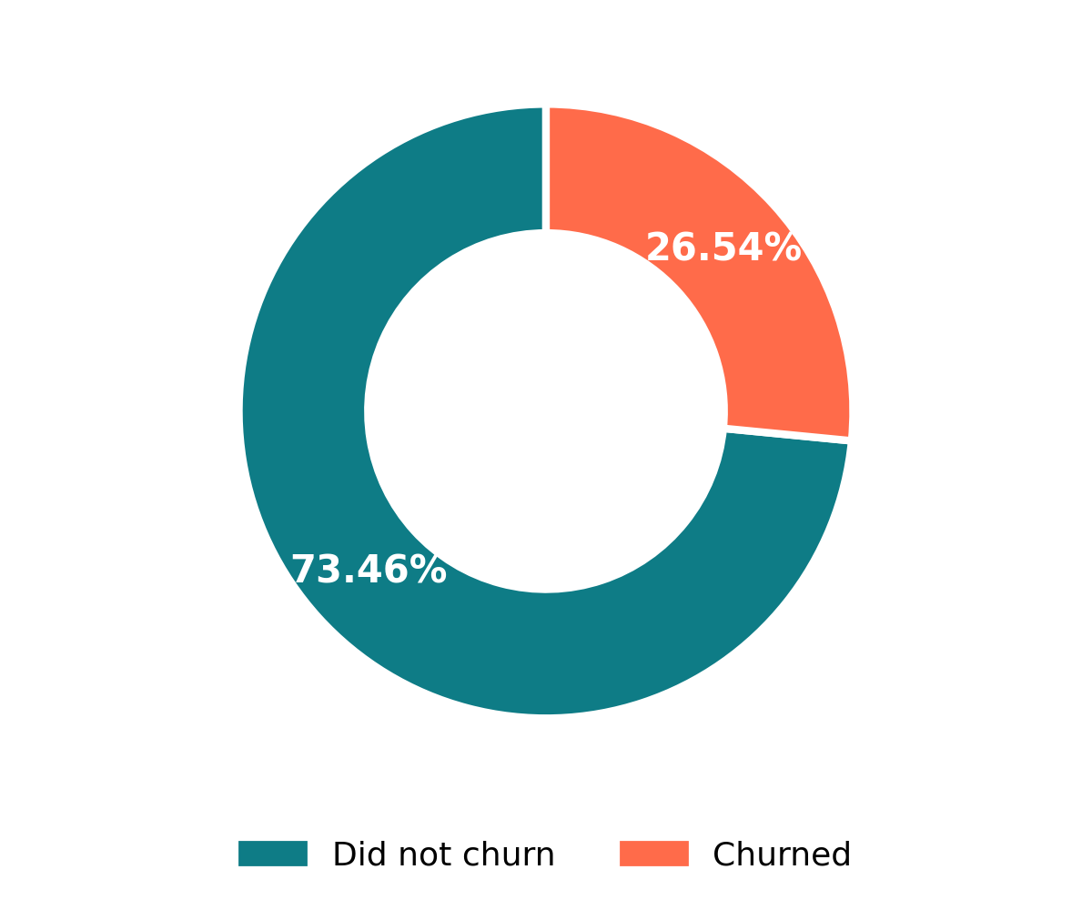
Figure 1. Overall customer churn distribution

Key EDA Finding: Churn by Internet Service Type
Fiber optic customers churn at a substantially higher rate than DSL or no-internet customers, making internet service type one of the clearest early signals of churn risk.
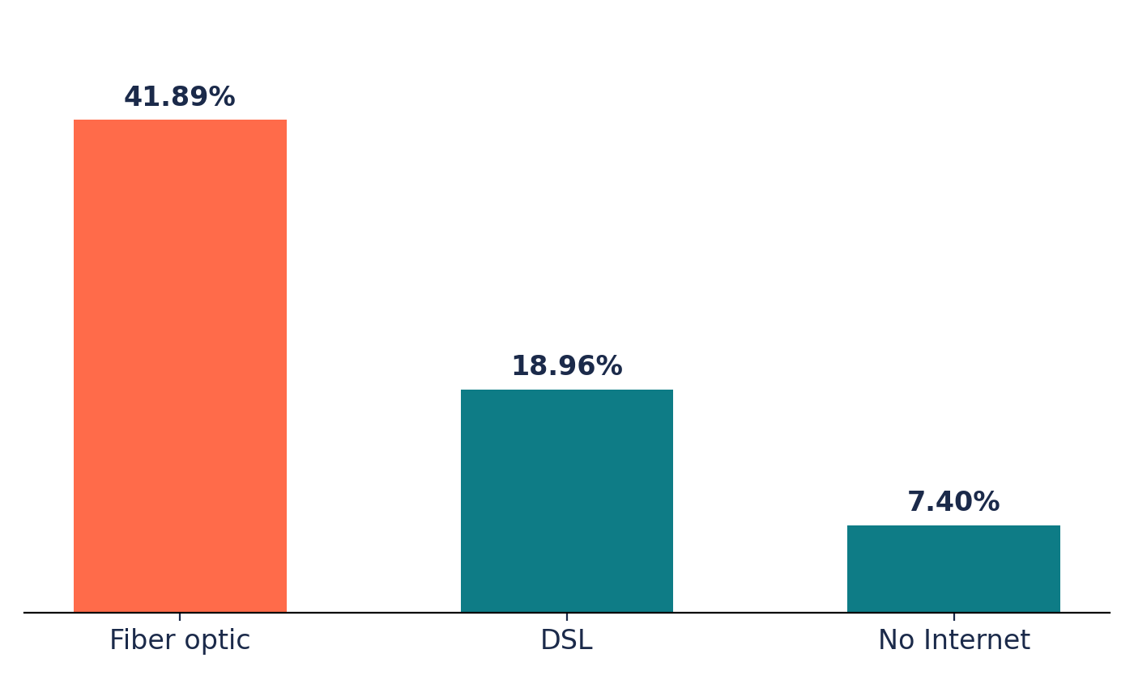
Figure 2. Churn rate by internet service type

5. Feature Engineering & Preprocessing

Engineered Features
- TotalChargesPerTenure — average total charges per month over customer tenure
- ServiceCount — number of selected subscribed services
- TenureGroup — groups customers by tenure duration

Preprocessing Steps
- Removed customerID from modeling
- One-Hot Encoding for categorical features
- StandardScaler for numerical features
- 80/20 stratified train-test split

6. Machine Learning & Optimization

Models Evaluated
- Logistic Regression — interpretable baseline classifier
- Random Forest — ensemble of decision trees
- XGBoost — gradient boosting model

Optimization Strategy
- 5-Fold Stratified Cross-Validation
- GridSearchCV for hyperparameter tuning
- ROC-AUC used as the tuning score

7. Final Model Performance
Model | Accuracy | Precision | Recall | AUC-ROC
Tuned Logistic Regression | 79.91% | 65.12% | 52.41% | 0.8418
Tuned Random Forest | 76.08% | 53.43% | 77.01% | 0.8387
Tuned XGBoost | 80.98% | 68.66% | 52.14% | 0.8473

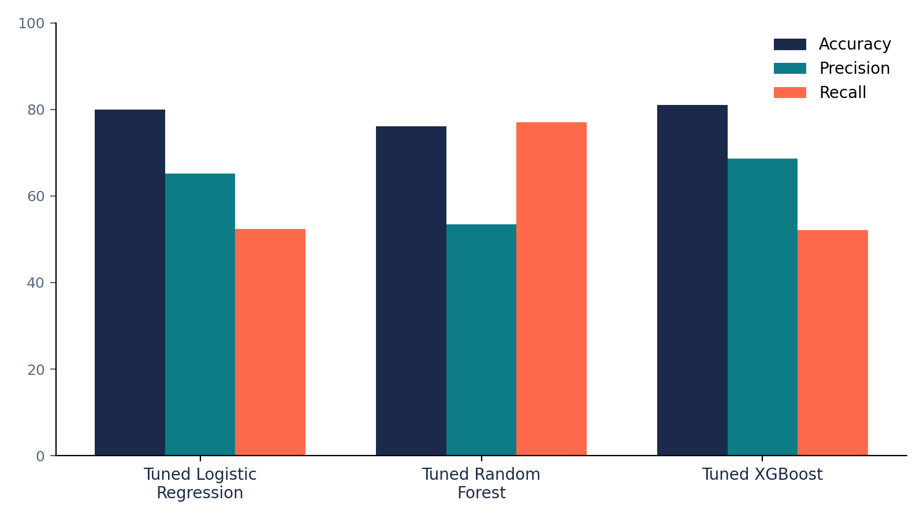
Figure 3. Comparison of accuracy, precision and recall across tuned models
Selected model: Tuned XGBoost
The tuned XGBoost model achieved the highest AUC-ROC (0.8473), accuracy (80.98%) and precision (68.66%) among the three candidates, making it the recommended model for deployment.

8. Confusion Matrix & ROC Curve
Evaluation of the tuned XGBoost model on the held-out test set shows strong separation between churned and retained customers, well above the random-guess baseline.
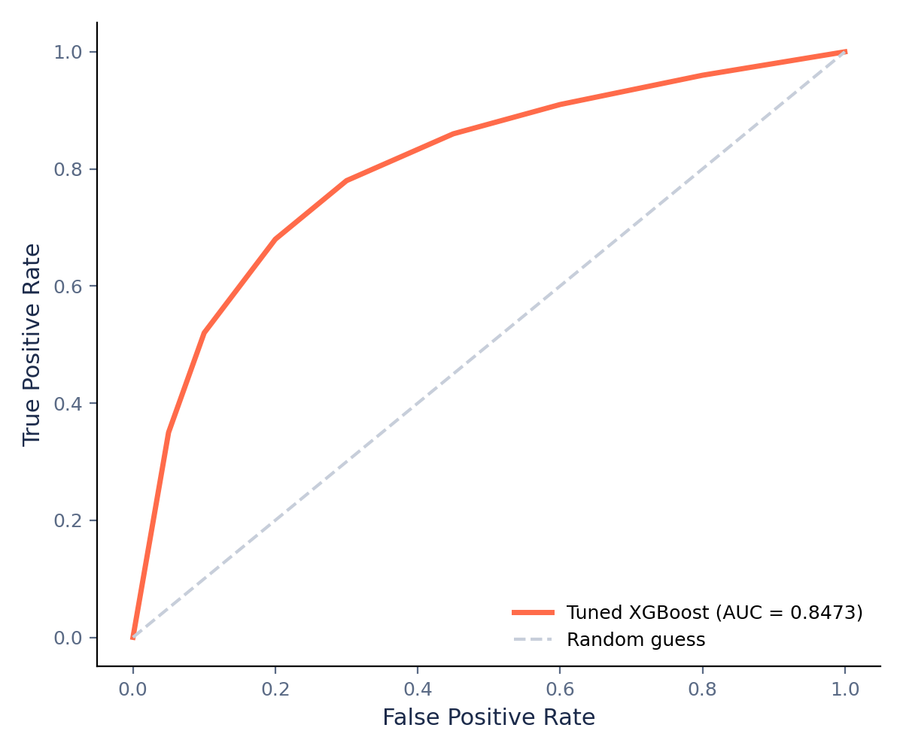
Figure 4. ROC curve for the tuned XGBoost model (AUC = 0.8473)

9. SHAP Analysis & Key Drivers
SHAP analysis was used to interpret which features most strongly influence the model's churn predictions. The leading drivers are:
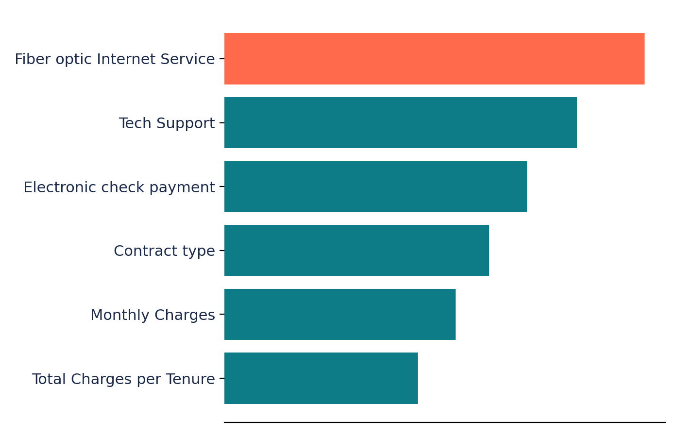
Figure 5. Relative importance of top churn drivers (SHAP)
- Fiber optic Internet Service
- Tech Support
- Electronic check payment
- Contract type
- Monthly Charges
- Total Charges per Tenure

10. Conclusion & Business Recommendations
Tuned XGBoost was selected as the final model with AUC-ROC = 0.8473.
- Use churn probabilities to prioritize high-risk customers.
- Focus retention efforts on higher-risk contract and service segments.
- Investigate the high churn observed among Fiber optic customers.
- Use personalized offers and loyalty incentives to reduce churn.
- Use SHAP explanations to support transparent, targeted retention decisions.

